Curriculum code: 6740

**DREAMWEAVER E-PROJECT**

**WILSON SPORTING GOODS.COM**

**GROUP MEMBERS:**

* WAJAHAT MANSOORI
* YASIR SALEEM
* UBAIKA
* ANAS ANSARI

**SUBMITTED TO:**

[‘eprojects@aptech.ac.in](mailto:eprojects@aptech.ac.in)

**PROJECT INSTRUCTOR:**

**‘MS RABIYA AMIN’**

**NAVBAR**



By Clicking on that button you will reach the

appropriate nav-item. This is Site of different Sports product’s…

**CATEGORIES**

**ACCESSORIES**

**WOMEN’S FOOTWEAR**

**WOMEN’S CLOTHING**

**MEN’S FOOTWEAR**

**MEN’S CLOTHING**

**DIFFERENT BRANDS PRODUCTS**

HOME PAGE

CLICK ON "HOME" PAGE & HOME PAGE WILL BE APPEAR……

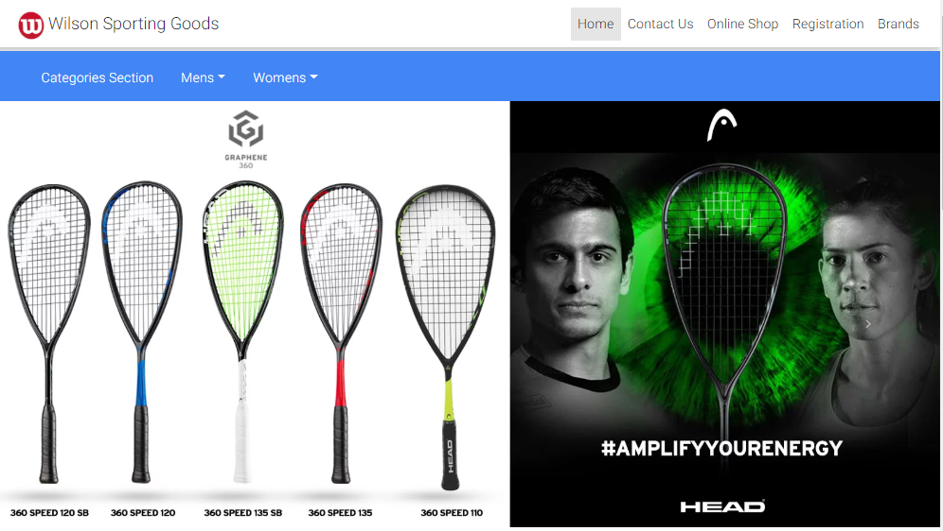

**CONTACT US**

CLICK ON "CONTACT US" PAGE & PAGE WILL BE APPEAR……



**ONLINE SHOP PAGE**

CLICK ON "ONLINE SHOP" PAGE & PAGE WILL BE APPEAR……

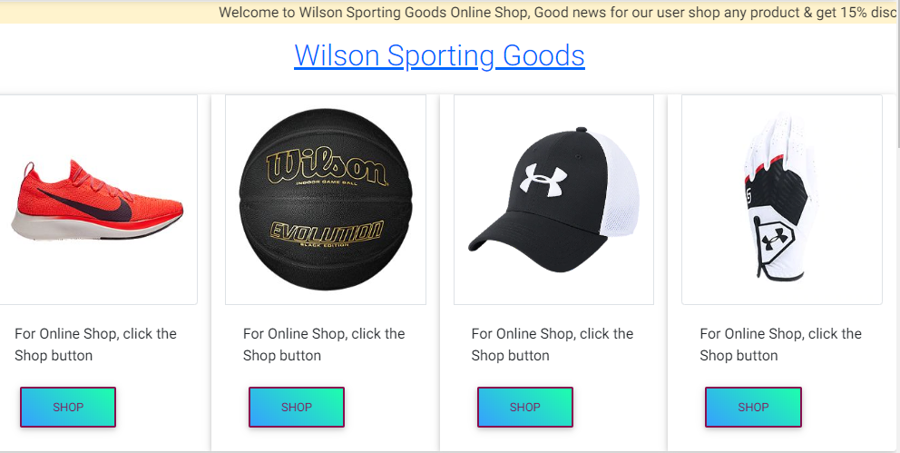

**REGISTRATION**

CLICK ON "REGISTRATION" PAGE & PAGE WILL BE APPEAR……



**BRANDS**

CLICK ON "ONLINE SHOP" PAGE & PAGE WILL BE APPEAR……

